Informed Consent Form for Participants in the DC4EU Pilot
at the Budapest University of Technology and Economics

Introduction
You are invited to take part in a pilot within the framework of the European project Digital Credentials for Europe (DC4EU). This document provides essential information about the processing of your personal data as a participant, in accordance with the General Data Protection Regulation (GDPR).
Please read this document carefully. By signing it, you confirm that you understand how your data will be used and that you freely consent to participate in this initiative.

Overview
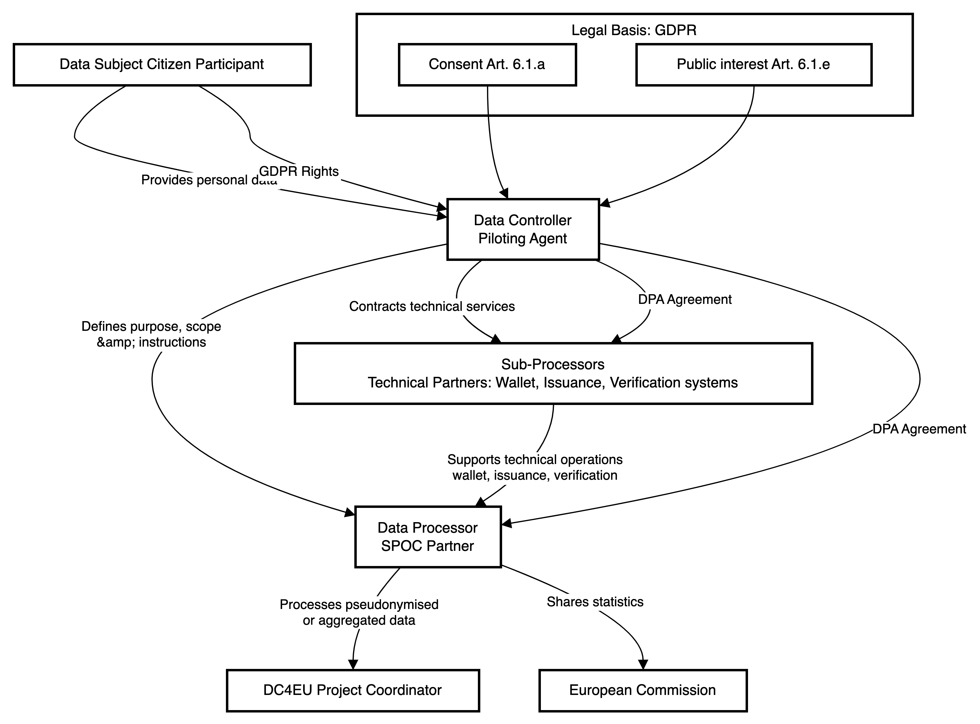

Data Controller
The data controller is the organisation responsible for determining the purposes and means of processing your personal data.
For this pilot, the data controller is:
Budapest University of Technology and Economics
1111 Budapest, Műegyetem rkp. 3
info@bme.hu
+3614631111

Purpose of the Data Processing
Your personal data will be processed solely for the following purposes, within the scope of the DC4EU project:
- To test and validate user journeys involving the issuance, sharing and verification of digital credentials through the EUDI Wallet.
- To assess the effectiveness, usability and user experience of the digital services and technologies used in the pilot.
- To generate indicators and statistics for improving the pilot solutions and reporting to the European Commission.
- To collect feedback, suggestions and concerns from users.
- To ensure compliance with EU legislation regarding digital identity, privacy and data protection.

Categories of Personal Data Collected
The categories of personal data that may be collected include:
- Basic identification data: full name, age, gender, nationality.
- Contact details: email address, phone number (if applicable).
- Digital identifiers: wallet identifier, pseudonymized technical identifiers.
- Credential data: educational or professional qualifications.
- Survey responses: opinions, satisfaction, usability ratings.
- Technical data related to service usage.
No special categories of data will be processed unless separately consented to.

Legal Basis for Processing
Your data will be processed based on:
- Your explicit consent (Article 6(1)(a) GDPR). You may withdraw your consent at any time.
- Tasks carried out in the public interest (Article 6(1)(e) GDPR), related to the DC4EU project funded by the EU Digital Europe Programme.

Data Recipients
Your data may be shared with:
- Project partners acting as data processors.
- SPOC partners for data analysis.
- Project coordinators and collaborators.
- The European Commission, only with aggregated or anonymized data.
No personal data will be transferred outside the EEA without appropriate safeguards.

Data Retention Period
Data will be retained:
- Until the completion of the DC4EU project.
- Up to two additional years for auditing.
- In pseudonymized or anonymized form when possible.
- Will be deleted upon consent withdrawal unless otherwise required by law.

Your Data Protection Rights
Under the GDPR, you have the right to access, rectify, erase, restrict, object, port your data, and withdraw consent.
To exercise these rights, contact the data controller or their DPO. You may also contact your national Data Protection Authority.

Security and Confidentiality
Appropriate technical and organisational measures are in place:
- Restricted system access.
- Pseudonymization.
- Encryption.
- Trained staff.
All partners have signed confidentiality and data protection agreements.

About the DC4EU Project and Your Participation
DC4EU is a pilot co-funded by the EU’s Digital Europe Programme (Grant Agreement No. 101102611).
It tests the use of digital credentials in education and professional contexts with the EUDI Wallet.
Participation is voluntary and free. Feedback helps shape future EU digital identity policy.

Automated Decision-Making and Profiling
No automated decisions or profiling with significant effects will be made. All processes are supervised.

Informed Consent and Signature
I, the undersigned, declare that:
- I have read and understood this information.
- I agree to voluntarily participate in the pilot.
- I give explicit consent for data processing.
- I know my rights under GDPR.
- I may withdraw my consent at any time.
Full name: _____________________________________________________
University ID (Neptun code): _____________________________________________________
ID document (optional): _____________________________________________________
Email address: _____________________________________________________
Date: June 12, 2025
_______________________________________
Signature

